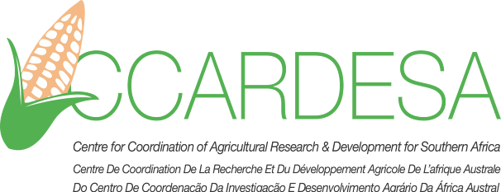
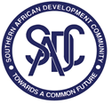

CONSULTANCY
DEVELOPMENT OF THE CCARDESA 10 YEAR STRATEGY AND MEDIUM TERM OPERATIONAL PLAN

1. BACKGROUND
The Centre for Coordination of Agricultural Research and Development for Southern Africa (CCARDESA) is a Subsidiary organisation of the Southern African Development Community (SADC). It was established in 2010 by Member States of SADC, and tasked with the mandate of coordinating agricultural research and development in the region. CCARDESA’s mandate is aligned to the Regional Indicative Strategic Development Plan, the SADC Regional Agricultural Policy and its investment plans, the CAADP/Malabo Declaration Commitment as well as the Sustainable Development Goals (SDGs). CCARDESA works closely with regional and international partners to facilitate generation and use of essential agricultural technologies and management practices. It also supports the exchange of information and technology among Member states.
2. ASSIGNMENT
The operations of CCARDESA are guided by its strategy and an operational plan. The current Medium Term Operational Plan (MTOP), which provides details of the technical focus of the organisation for a period of 5 years, will elapse on 31st December 2018. The organisation therefore needs to develop a new Strategic Plan which will provide the priority boundaries of operation of CCARDESA for the next 10 years. The content and orientation of the CCARDESA strategy will be based on the available regional strategic priorities, current topical issues and envisaged trends of interest to the agricultural sector. The Strategy will be accompanied by an MTOP, which will articulate the operational details for the next 5 years. The MTOP is therefore the action guiding tool for achieving the objectives and targets of the Strategy.
CCARDESA is therefore inviting applications from qualified and experienced individuals to carry out the task of developing its 10 year Strategy and a Medium Term Operational Plan for 5 years. This is one assignment but requires the services of two experts. Therefore it is applicants are required to submit their bid as a pair of two experts with profiles indicated in the Terms of Reference. Details of the assignment are contained in the attached TORs.
3. SUBMISSION OF BIDS
Applicants should submit their bids in two parts: the first part will contain a well-articulated technical offer providing, among other things, a background, methodological approach, data collection, key information to be gathered for the assignment, consultation process, categories of stakeholders to be consulted, key components of the Strategy and operational plan, and any other relevant details for this assignment.
Bidders should present their technical bids using Times New Roman Font, 1.15 line spacing and 12 point font size. The bid should not exceed 10 pages. Bidders should also attach detailed CVs of the two experts proposed for the assignment. Please note that the pages of the CVs are ADDITIONAL to the 10 pages mentioned above.
Submit your technical offer to Mmileng (gmmileng1@ccardesa.org) with a copy to S. Mwale (smwale@ccardesa.org). Submission of hard copies through courier services is also acceptable, and should be addressed to the Programmes and Grants Manager, CCARDESA Secretariat, 4701 Station Exit Road, P/Bag 00357, Gaborone, Botswana.
Bidders shall also submit a financial offer in a separate email, specifying only the fees per day for each of the two experts. The Financial offer should be sent to Simon Mukuze (smukuze@ccardesa.org) with a copy to Botho Maapatsane (bmaapatsane@ccardesa.org). You may also submit the financial offer by courier services, addressed to the Finance Manager, CCARDESA Secretariat, 4701 Station Exit Road, P/Bag 00357, Gaborone, Botswana.
4. DEADLINE
All bids (technical and financial) must be received by CCARDESA not later than 1630hrs (Botswana time) on Friday, 20th November, 2018
5. CONTACT PERSON:
For clarifications or enquiries related to this consultancy, you may contact Mr. Simon Mukuze (smukuze@ccardesa.org) phone: +267 3914997

