**National Agricultural Policy (NAP) for Lesotho**

**Diagnostic Report Validation Workshop**

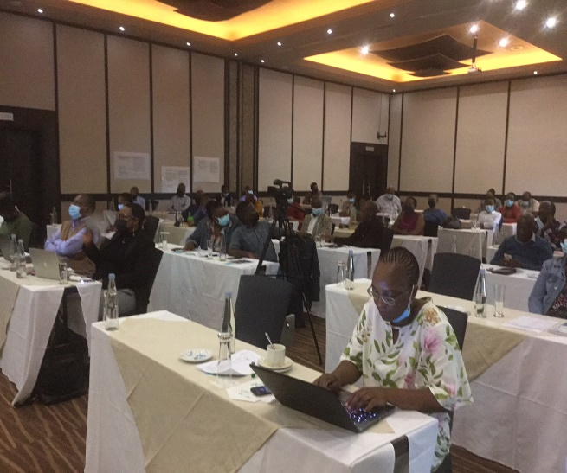 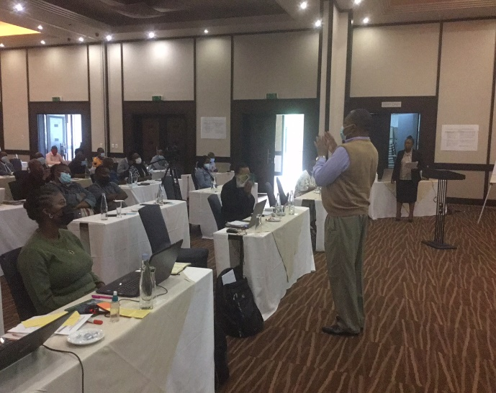

The Ministry of Agriculture and Food Security with funding from FAO, is undertaking the development of the National Agricultural Policy for Lesotho. For this policy to be in place, several activities were undertaken such as the diagnosis processes. In January 2022, a validation of the diagnostic report was held for the stakeholders who were involved during the consultations. The objectives of this diagnostic report as well as the validation workshop were to analyze the context of the agricultural sector in Lesotho with a view to understand its strengths, weaknesses, opportunities and threats in order to identify gaps and possible policy responses towards addressing the identified gaps. Results from the Report and validation will be used to develop the comprehensive National Agricultural Policy for Lesotho.

During the validation, consultants gave a presentation of the diagnostic report which was divided into three parts. Part 1 was the introduction, Part 11 which was the longest, provided the sector diagnosis split into six (6) priority areas. The first part starts with the economic significance of agriculture in Lesotho, which sets the stage for further discussion on how agriculture in the country is organized in terms of production and productivity; the necessary infrastructure, marketing and required value chains, research and innovation supporting the sector, issues of health and nutrition, as well as emergency preparedness and lastly institutions, policy and legal framework guiding agriculture. The presentation concluded with the way forward towards NAP completion in Part III.

After the presentations, participants were divided into six priority areas as shown by the pictures below. The purpose of this exercise was for the participants to see if there were issues that were left out and if so, they were at liberty to fill those gaps. The following pictures show some of the additions that were made to different priority areas.

